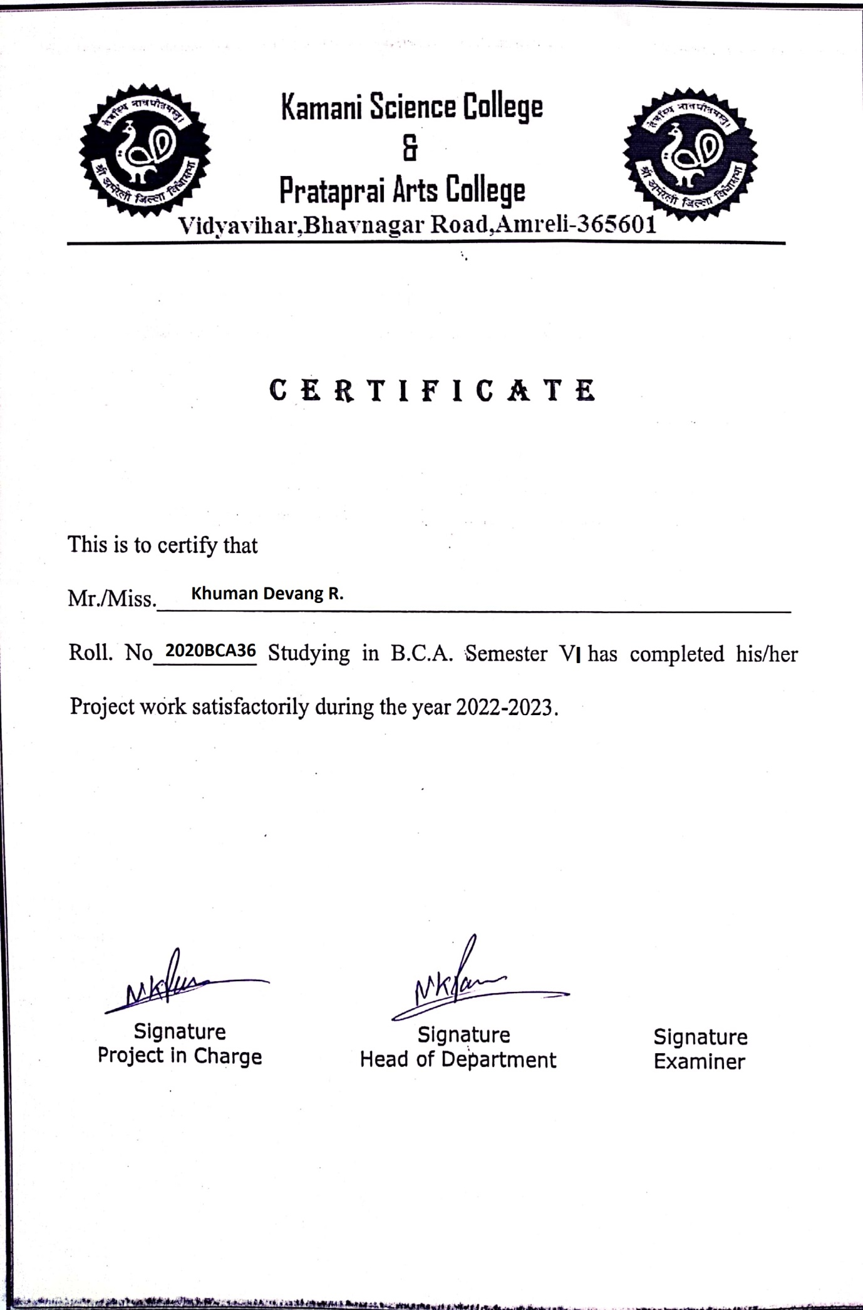

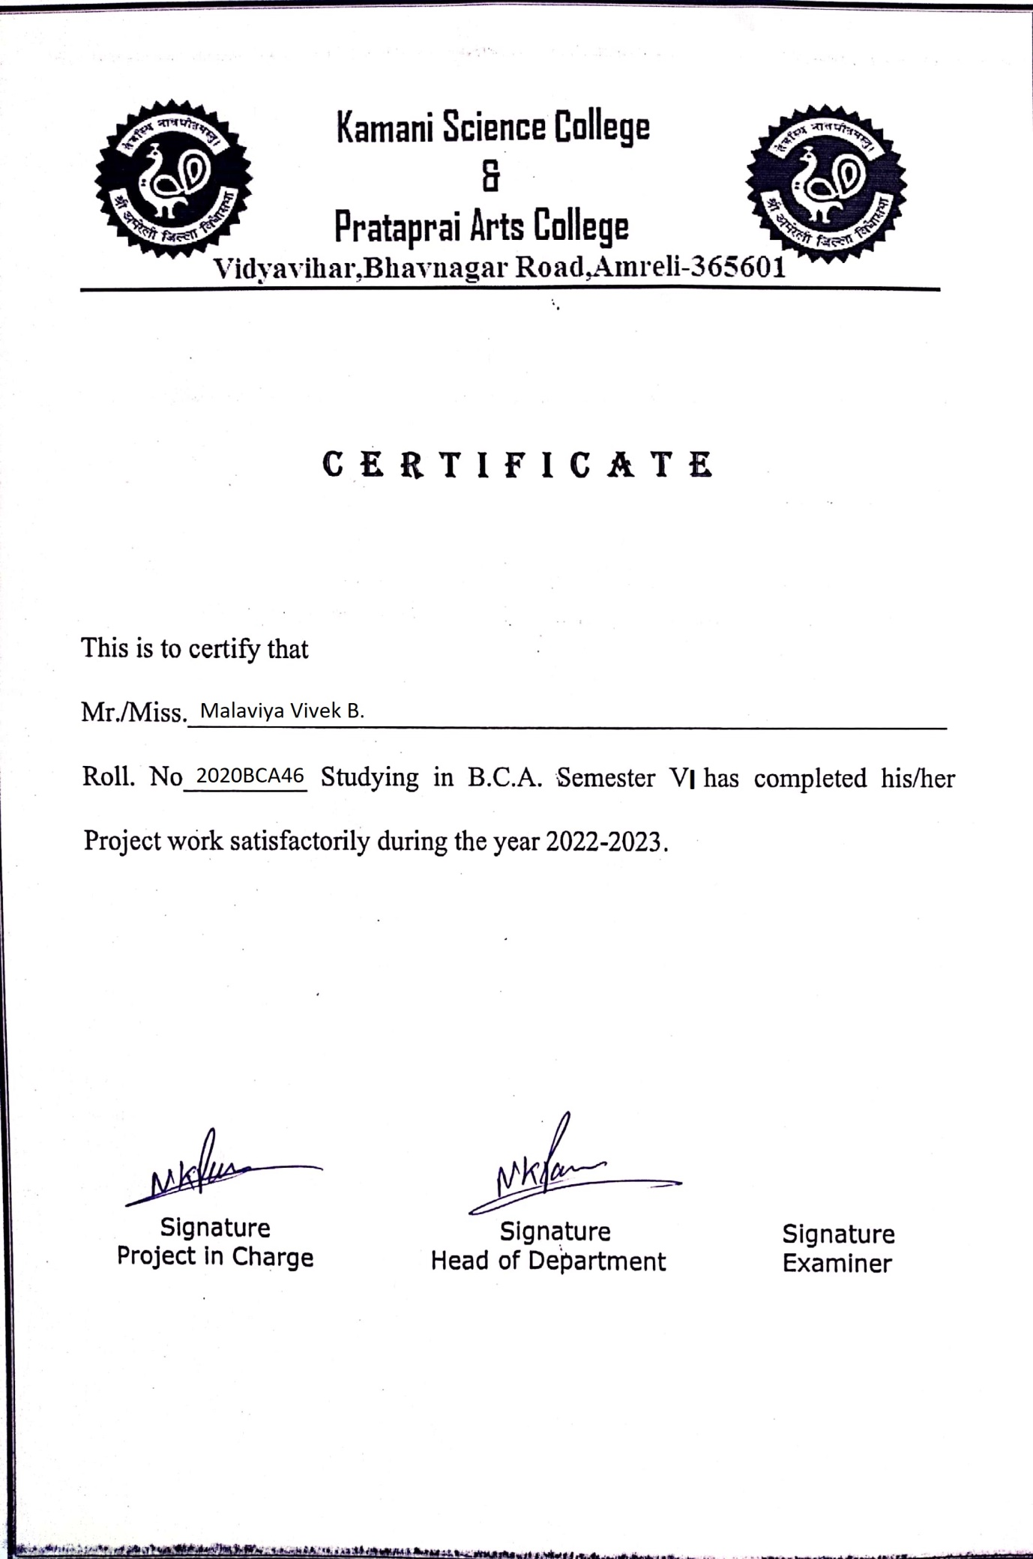

**-: PREFACE :-**

* The main objective of any computer science student is to get practical knowledge as possible. Being able to have a practical knowledge by developing a project is a lifetime experience. As practical knowledge is important as theoretical knowledge we are thankful of having a project.
* Through the development of the project we had a great experience of various strategies that can be applied in development of the project. This project is the stepping stone for our career.
* We are pleased to present this project report. Proper case has been taken while organizing the report so that it is easy to comprehend. Also, various software engineering concepts have been implemented.

**-: acknowledgement :-**

We are students of BCA sem-5 Studying in the Kamani Science and Prataprai Arts College, Amreli. We are thankful to the entire person who has given their support in shaping of the system.

We thanks to all the our teacher’s for giving us guidance and Co-operation in understanding the system. We also thank them for their unconditional help in making of this project.

We have great deal of gratitude towards our Head of Department who encourage us in taking up this activity. We thank all faculties and administrative staffs of the institute.

**Thanks to all !**

**-: Index :-**

|  |  |  |
| --- | --- | --- |
| No | Title | Page No |
| 1 | **Introduction** | 6 |
| 2 | **Time-line Chart** | 7 |
| 3 | **Project Profile** | 8 |
| 4 | **Hardware Requirement** | 9 |
| 5 | **Software Requirement** | 9 |
| 6 | **Requirement Specification** | 10 |
| 7 | **Problem Definition** | 10 |
| 8 | **Project Planning & Scheduling** | 11&12 |
| 9 | **System Analysis** | 13 |
| 10 | **Project Page Structure** | 16 |
| 11 | **Data Dictionary** | 18 |
| 12 | **Data Flow Diagram** | 22 |
| 13 | **ER Diagram** | 25 |
| 14 | **Use case Diagram** | 26 |
| 15 | **Activity Diagram** | 27 |
| 16 | **Screen shot** | 29 |
| 17 | **Future Scope** | 37 |
| 18 | Bibliography | 38 |

**-: Introduction :-**

**I**n today’s world many people wanted to save and make money so they invested in stocks,crypto,sip,Forex etc. but many of them didn’t have deep knowledge about market, so we come up with this site that provide many courses about market about deep analysis, chart, patterns etc topics covered with various crash courses. Here people can explore many courses and buy them and learn about various market.

Propose of this site to provide below facilities to the users.

1. People can buy courses about market.

2) After buying course they learn about market and

make money.

3) This site is maintained user privacy strictly.

**-: Timeline Chart :-**

**Preliminary Investigation**

**Analysis**

**Design**

**Coding**

**Testing**

**Documentation**

**-: Project Profile :-**

|  |  |
| --- | --- |
| Project name | Online Course Selling System |
| Developed by | Devang Khuman  Vivek Malaviya |
| Frontend tool | ASP.NET |
| Backend Tool | Sql server 2012 |
| Operating system | Microsoft windows XP &Microsoft window 7 or 10 |
| Computer system | Intel i3 or higher, Ram:2 GB |
| Project Details | This site gives users to courses to learn about various market. |
| Completion time | 2.5 Months |
| Guide by | Mr. Ravi Joshi |
| Submitted by | Saurashtra University, Rajkot |

**-: Hardware Requirement :-**

* 256+MB of RAM
* Multimedia Keyboard, Mouse
* CPU and Monitor
* 1.0+GHz Processer
* Printer

**-: Software Requirement :-**

* Operating System :- Microsoft Windows 7 or 11
* Front-End Tool :-ASP.NET
* Back-End Tool :-Sql Server 2012
* Documentation Tool :- Microsoft word-2007
* Browser Specification :- Google Chrome or Edge

**-: Requirement Specification :-**

* SQL Server maintain the all concerned data.
* Display all types of data using classified reports with combinations of multiple data base table.
* Controlling the information regarding whole network site.

**-: Problem Definition :-**

* Maintain Users Profile
* Maintain Users Privacy
* Managing course

**-: Project Plannig & Scheduling :-**

**N**ow a day's people wanted to make money or save money for futures by investment in various sectors. In those sectors one sectors is Market and it could be like Stocks, Crypto, Mutual Funds, Forex etc.in this markets many people invest there money without any basic or deep knowledge and after they realise that they make a mistake. If you wanted to do something new than first of all you have to learn that thing line by line it also applies that in investment plan or trading. If you wanted to do trading than you have learn and gain knowledge about any markets do you wanted to invested if you learn perfectly than you can make some kind of money form the markets. So, we provided courses about the markets in this courses people can get deeply knowledge about particular trading topics or maybe they learn whole concept of market. In this site people can buy the course whatever what they want and learn something new.

**-: Project Plannig & Scheduling :-**

**Implementation**

**Maintenance**

**Testing**

**Coding**

**System Design**

**System Analysis**

**Priliminary Investigation**

**-: System Analysis :-**

**S**ystem analysis is the process of identification of objectives and requirements, evaluation of alternative solutions and recommendation for a more feasible solution. In other words, system analysis is the step by step process of gathering, recording and interpreting facts. The main aim of analysis is to determine problem areas and to take solutions to reduce or eliminate them.

* **System analysis itself breaks into two stages:**

**1.** Preliminary analysis

**2.** Detailed analysis

During analysis, data are collected from the available Files, decision points and transactions of the systems using Various tools like **Data Flow Diagram (DFD).**

**-: Feasibilty Study :-**

**A** purpose of feasibility study is to check out the possibility of a computerized solution to the organization’s observed problem before very much money that has been spent on.

A feasibility study is carried out to select the best system that meets performance requirements, only by spending the time to evaluate to feasibility do I reduce the chances for extreme embarrassment at later stage of the system project.

For the complete feasibility study I need to concentrate on following area:

**They are of Three types:**

**1.** Technical

**2.** Operational

**3.** Economical

* **Technical :-**

Technical feasibility considers whether the desired project can be completed within the framework of available technology. As our project was website designing, this was not much of a problem, as many advanced web-editing tools are available.

* **Operational:-**

**O**perational feasibility was done to assure that the product that would be developed would be used. Since a cards and gifts has to have a website of its own sooner or later, that wasn’t much of a problem.

* **Economical:-**

**O**ur Commercial Website is Economically Feasible Because. We have developed this website only for one time. Only future enhancement is required on the other hand every client can view our site any time or many time as per their requirement. So the future economical expenses are null. So we can say that this website is totally economically feasible.

**-: Project Page Structure :-**

* **Client Side:-**

**Client Side**

**Create Account**

**Login**

**Buy Course**

**View Course**

**Logout**

**About us**

**Contact us**

**Logout**

**Delete Feedback**

**Edit Feedback**

**delete product**

**Login**

**Add product**

* **Admin Side:-**

**View Category**

**Tables**

**Login**

**Admin Side**

**View Course**

**Delete Category**

**Delete Admin**

**Delete Course**

**Add Course**

**Add Admin**

**Logout**

**Add Category**

**-: Data Dictionary :-**

The data Dictionary is a set of table. MySQL uses it to maintain information about his own database.

* **Data dictionary contains the following information:**

* Name of the table of database.
* User information such as privileges.
* Name and data-type of all columns in database table.

**Database name :** tradesmint.mdf

**1.users :-**

* **T**his table is used to stores the users information.

|  |  |  |  |
| --- | --- | --- | --- |
| Field | Type | Size | Constraint |
| Id | int | 11 | Primary key |
| firsname | nvarchar | 50 | **-** |
| lastname | nvarchar | 50 | **-** |
| email | nvarchar | 50 | **-** |
| mobile | nvarchar | 50 | **-** |
| password | nvarchar | 50 | **-** |

**2.admin :-**

* **T**his table is used to store admin information.

|  |  |  |  |
| --- | --- | --- | --- |
| Field | Type | Size | Constraint |
| Id | int | 10 | Primary key |
| firsname | nvarchar | 50 | - |
| lastname | nvarchar | 50 | - |
| email | nvarchar | 50 | - |
| mobile | nvarchar | 12 | - |
| password | nvarchar | 50 | - |

**3.cart:-**

* **T**his table is used to store cart information.

|  |  |  |  |
| --- | --- | --- | --- |
| Field | Type | Size | Constraint |
| Id | int | 12 | Primary key |
| c_id | int | 12 | - |
| c_uid | int | 12 | - |

**4.category :-**

* **T**his table is used to store category information.

|  |  |  |  |
| --- | --- | --- | --- |
| Field | Type | Size | Constraint |
| Id | int | 12 | Primary key |
| ca_name | nvarchar | 50 | - |
| ca_subcategory | nvarchar | 50 | - |

**5.courses :-**

* **T**his table is used to store courses details.

|  |  |  |  |
| --- | --- | --- | --- |
| Field | Type | Size | Constraint |
| Id | int | 11 | Primary key |
| c_name | nvarchar | 50 | - |
| c_prize | nvarchar | 10 | - |
| c_disc | nvarchar | MAX | - |
| c_img | nvarchar | MAX | - |
| c_category | nvarchar | 50 | - |
| c_file | nvarchar | MAX | - |

**6.payment_info :-**

* **T**his table is used to store payment_info details.

|  |  |  |  |
| --- | --- | --- | --- |
| Field | Type | Size | Constraint |
| Id | int | 11 | Primary key |
| email | nvarchar | MAX | - |
| p_id | nvarchar | 50 | - |
| c_number | navarchar | 50 | - |
| c_name | navarchar | 50 | - |
| cvv | navarchar | 50 | - |
| date | navarchar | 50 | - |
| total | int |  | - |

**7.contact_info :-**

* **T**his table is used to store vehicle_info Detais.

|  |  |  |  |
| --- | --- | --- | --- |
| Field | Type | Size | Constraint |
| Id | int | 10 | Primary key |
| name | nvarchar | 50 | - |
| email | nvarchar | 50 | - |
| subject | nvarchar | 50 | - |
| message | nvarchar | MAX | - |

**-: Data Flow Diagram :-**

The DFD gives brief idea on how the designed system is working. It also suggests to us the type of users who using this system and the process involved in the system. The DFD gives brief idea on how the designed system is working. It also suggests to us the type of users who using this system and the process involved in the system.

**Represent Entity**

**Represent a System Processing**

**Represent a Data Flow**

**Represent a data store table**

**-:Context Level Diagram :-**

**Account Created**

**New Account Created**

**Account Created**

**Create New Account**

**Admin**

**User**

**Process to Login**

**Make Login**

**Uname & Pass Match**

**Redirect to home page**

**-:1st Level Diagram :-**

**Process for Login**

**Make Login**

**Login Successfully**

**Request for courses**

**Request for courses**

**Delivered request**

**courses**

**Delivered request**

**Buying Courses**

**Request for course**

**Deliver Request**

**Request Delivered**

**Contact**

**User**

**Contact**

**Admin**

**Add Category/Course**

**Adding Cat./Cou.**

**Category/Course Added**

**Deliver Request**

**category**

**Redirect to download**

**Processing Payment**

**payment_info**

**Payment Done**

**Return to Login page**

**Request to Logout**

**Logout Success**

**Logout Requested**

**Request for Payment**

**-: ER Diagram :-**

**has**

**courses**

**payment_info**

**cart**

**has**

**users**

**-: Usecase Diagram :-**

**Online Course Selling System**

**Admin**

**User**

**-: Activity Diagram :-**

* **Client Side:-**

**Login**

**Check id & pass**

**Create Account**

**Payment**

**Logout**

**View Course**

**Buy Course**

**Contact Us**

**Valid** **Invalid**

* **Admin Side:-**

**Check id & pass**

**Login**

**Create Account**

**Add Category**

**Delete Course**

**Delete Category**

**Delete User**

**Logout**

**Edit Course/Category**

**Add Course**

**Valid** **Invalid**

**-: ScreenShots:-**

**Admin:**

**Admin Login Page:-**

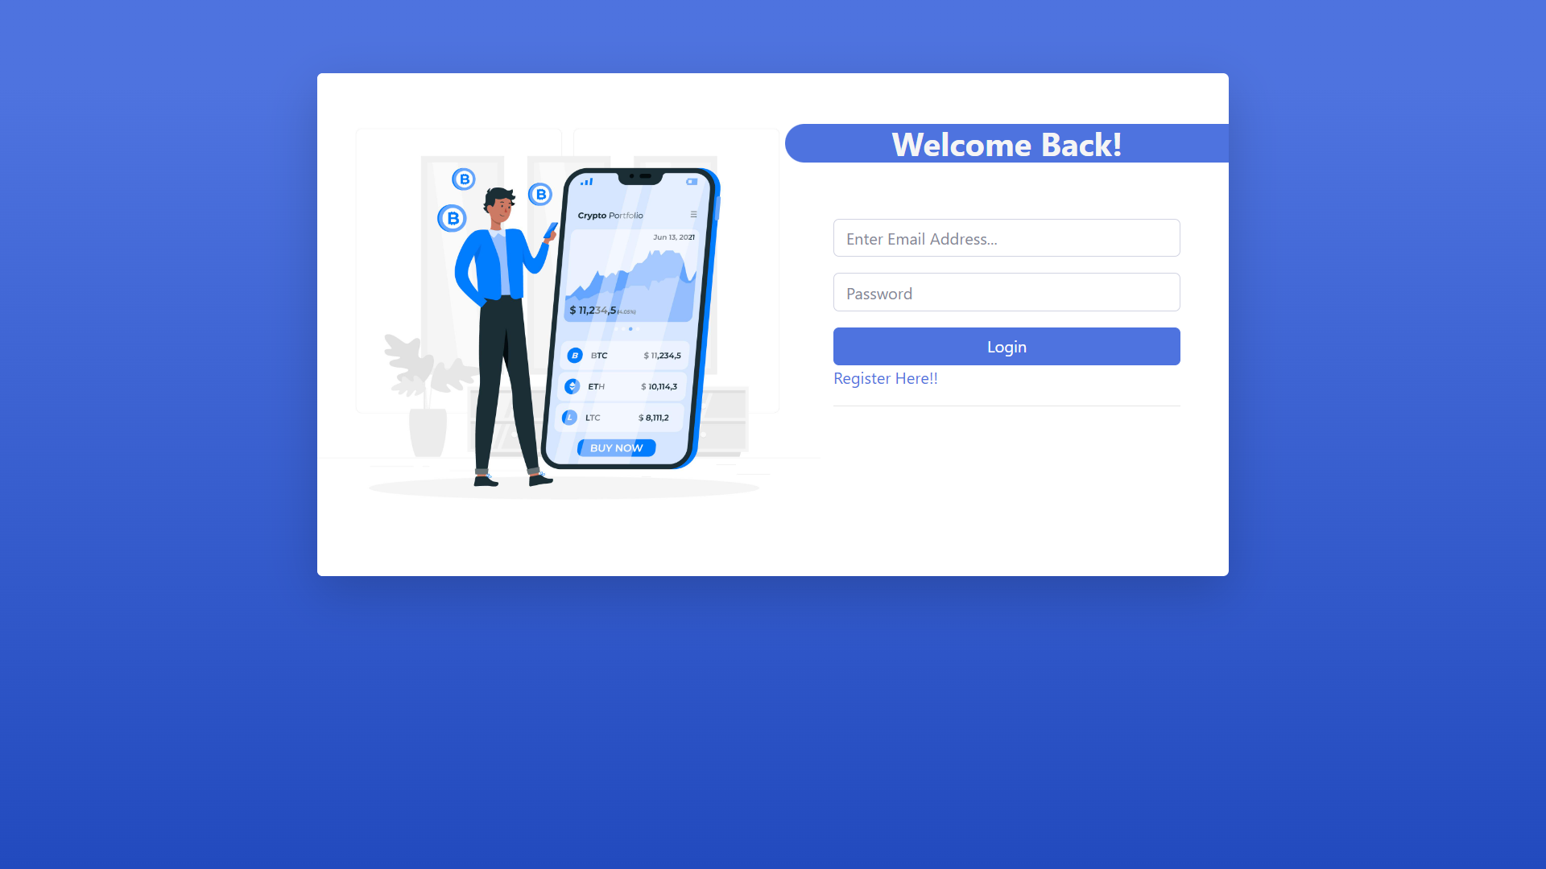

**Admin Sign Up Page:-**

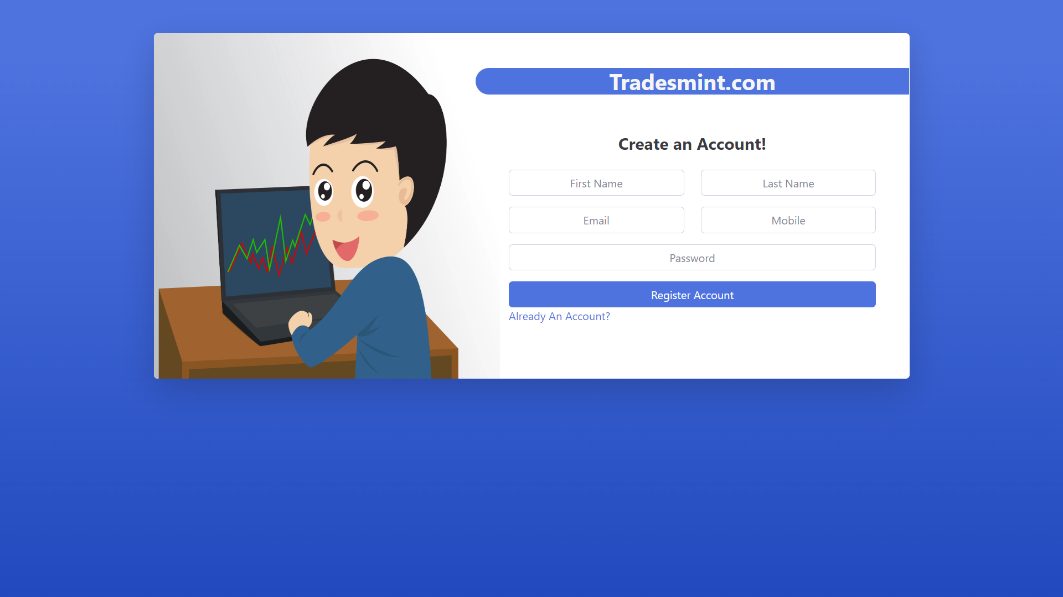

**Admin Dashboard:-**

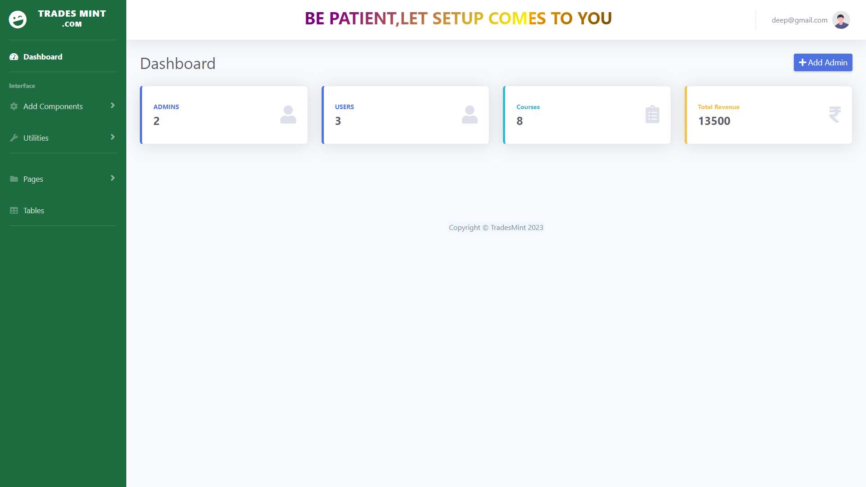

**Add Category Page:-**

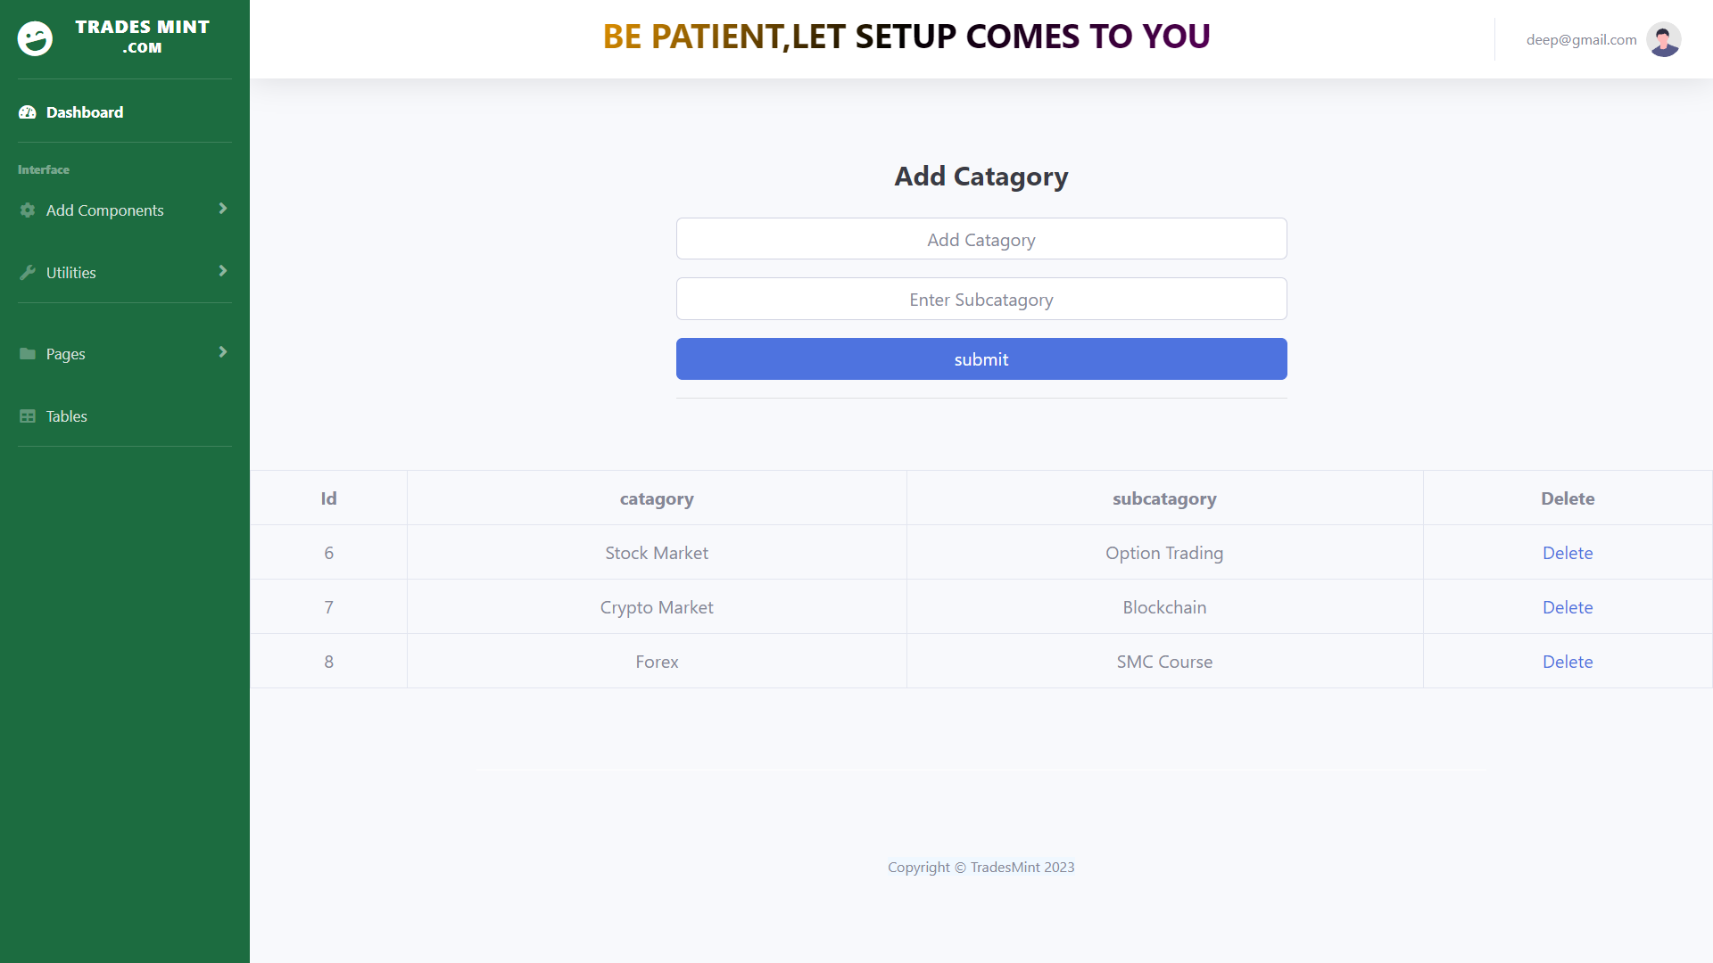

**Add Course Page:-**

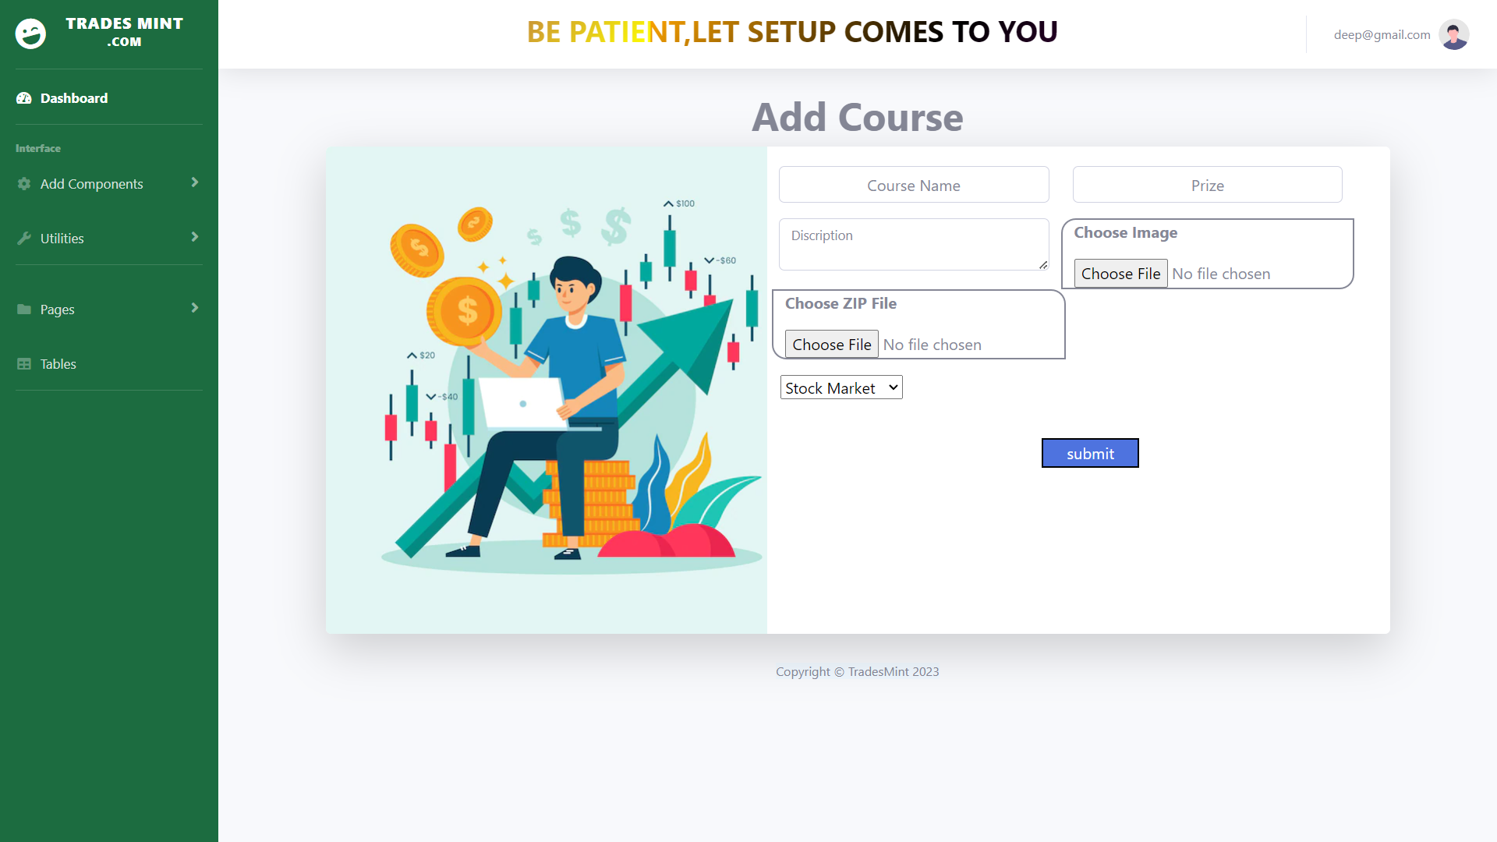

**Payment Info Page:-**

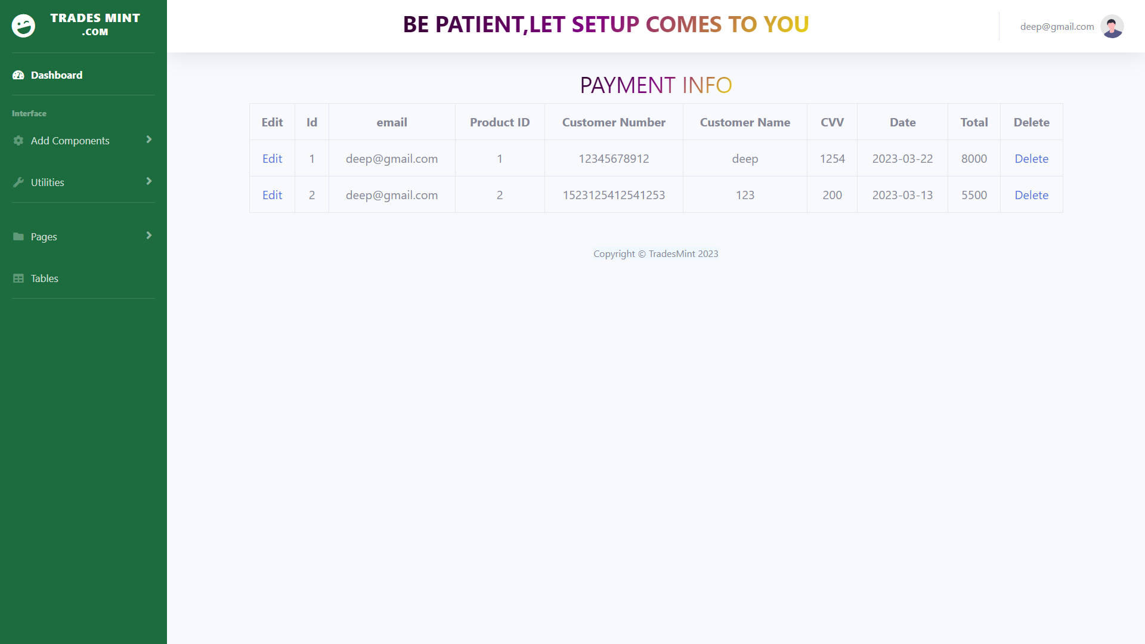

**Courses Page:-**

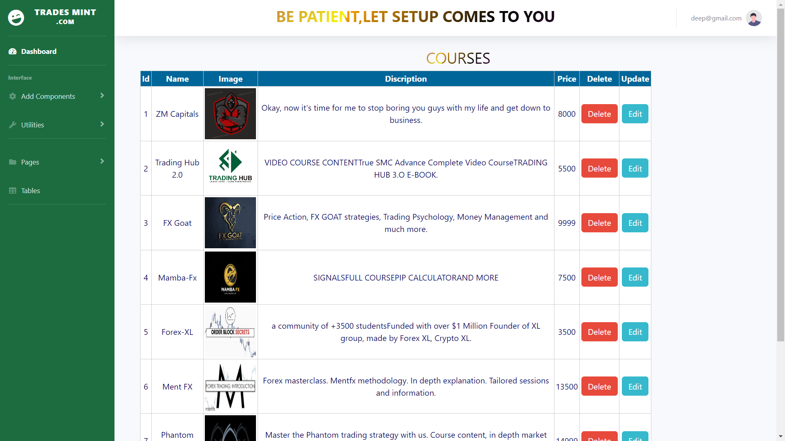

**Tables Page:-**

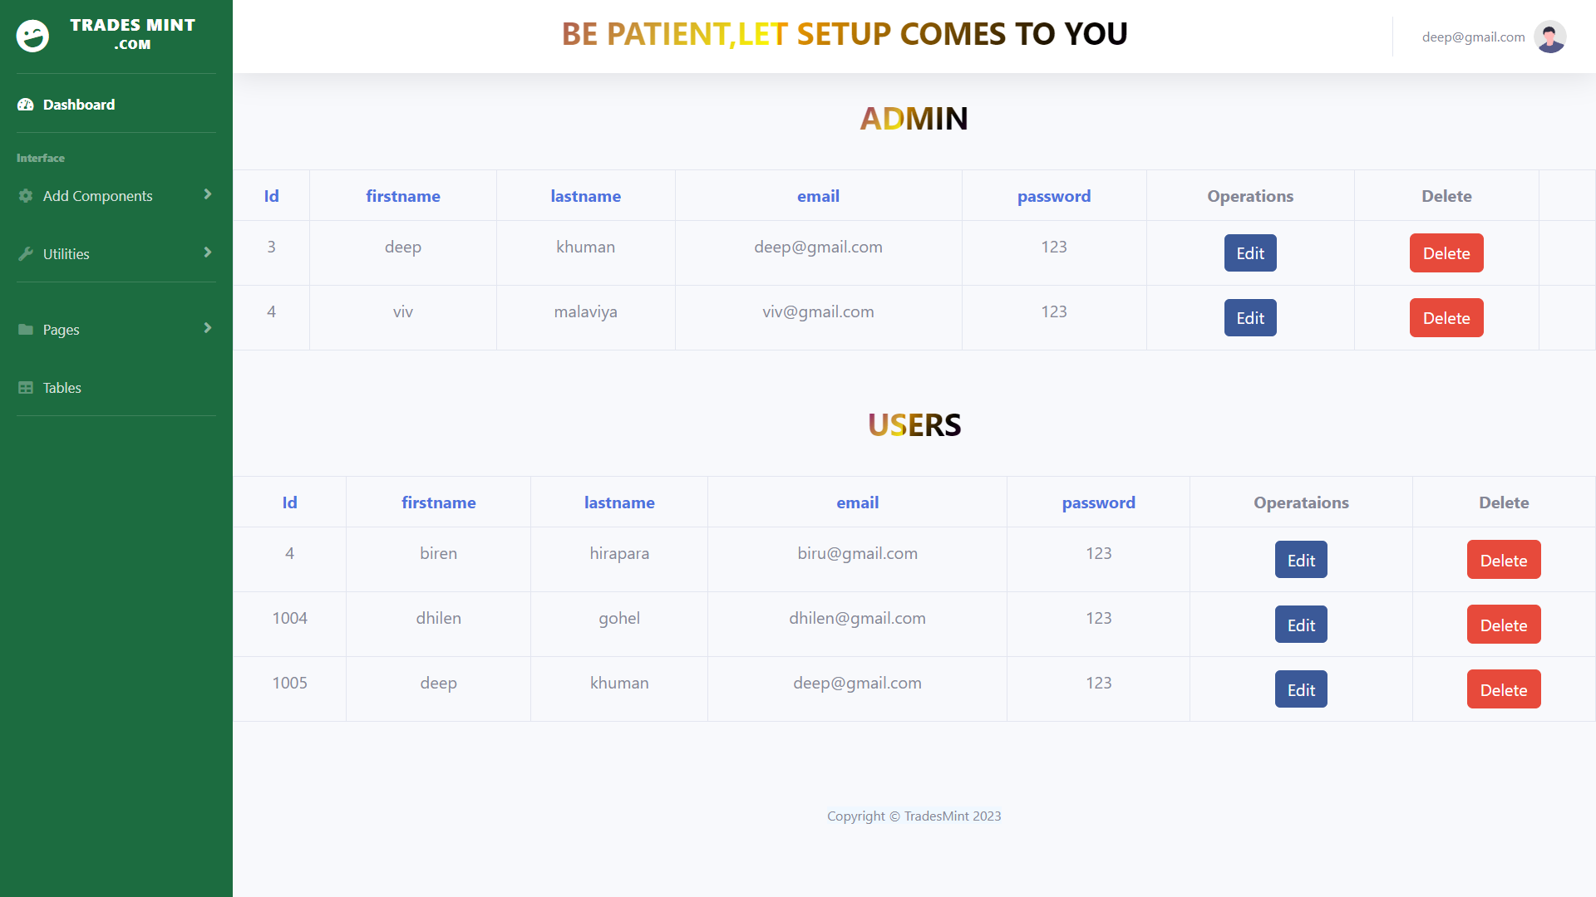

**Add Admin Page:-**



**User:**

**Clients Login Page:-**



**Clients Sign up Page:-**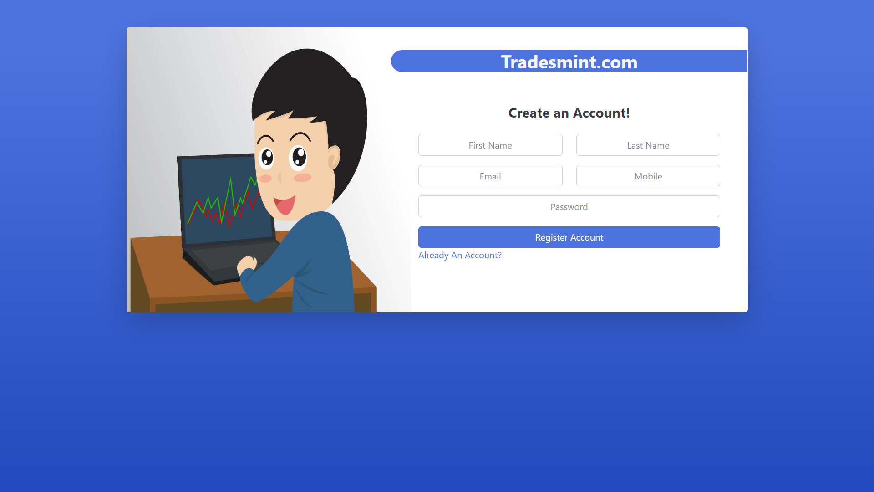

**Home Page:-**



**About Us Page:-**

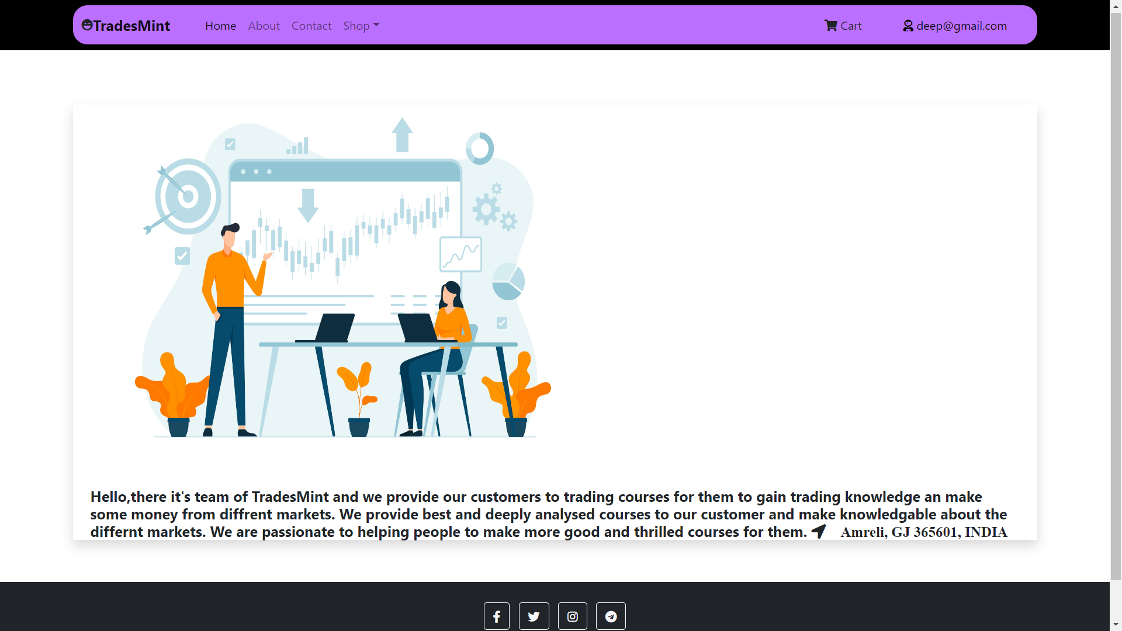

**Contact Us Page:-**

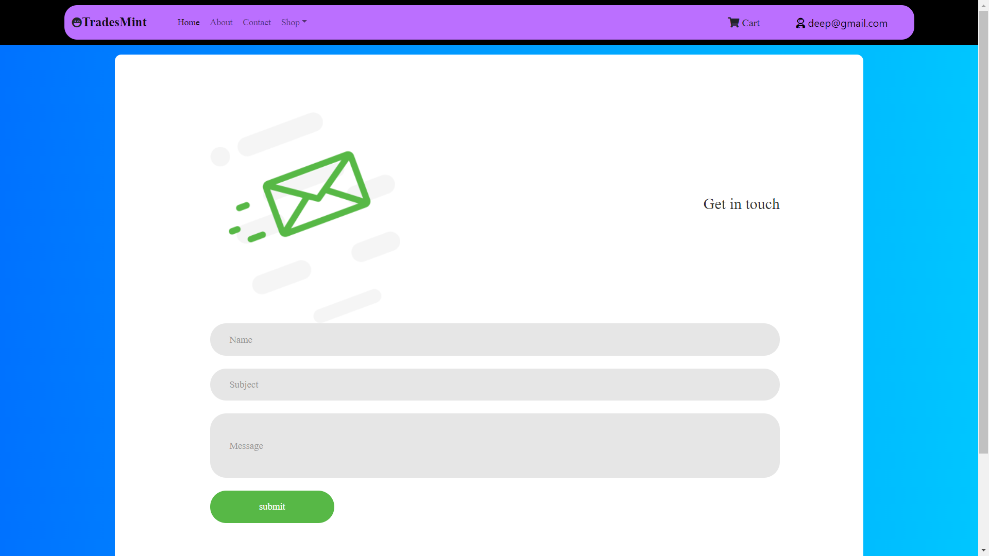

**Cart Page:-**

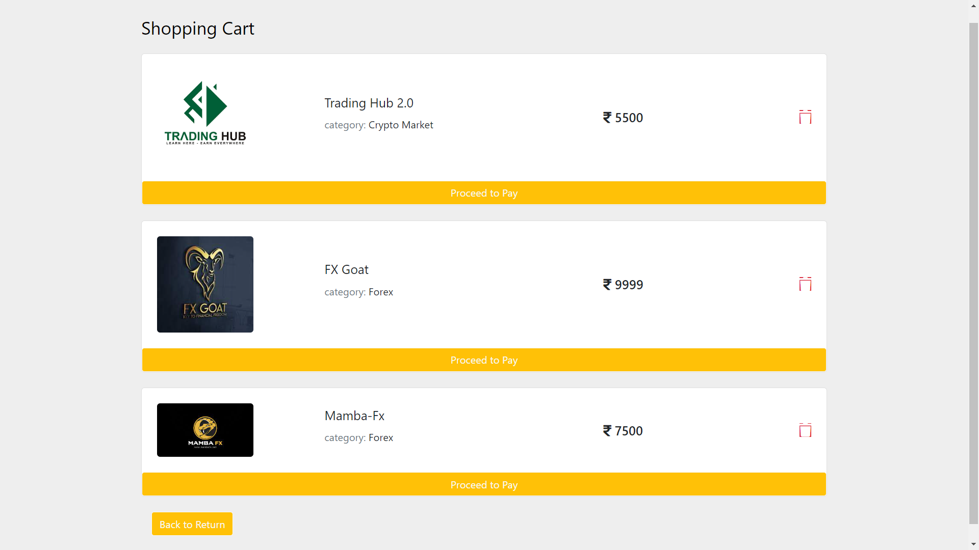

**Download Page:-**

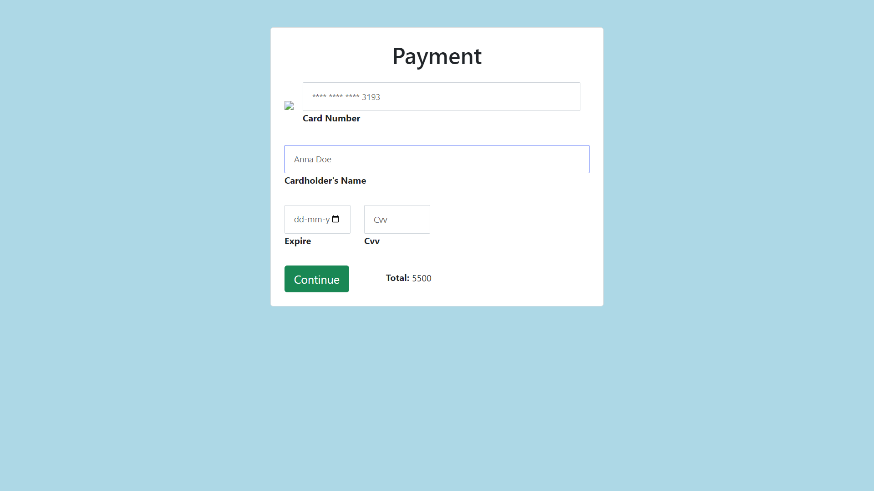

**Download Page:-**

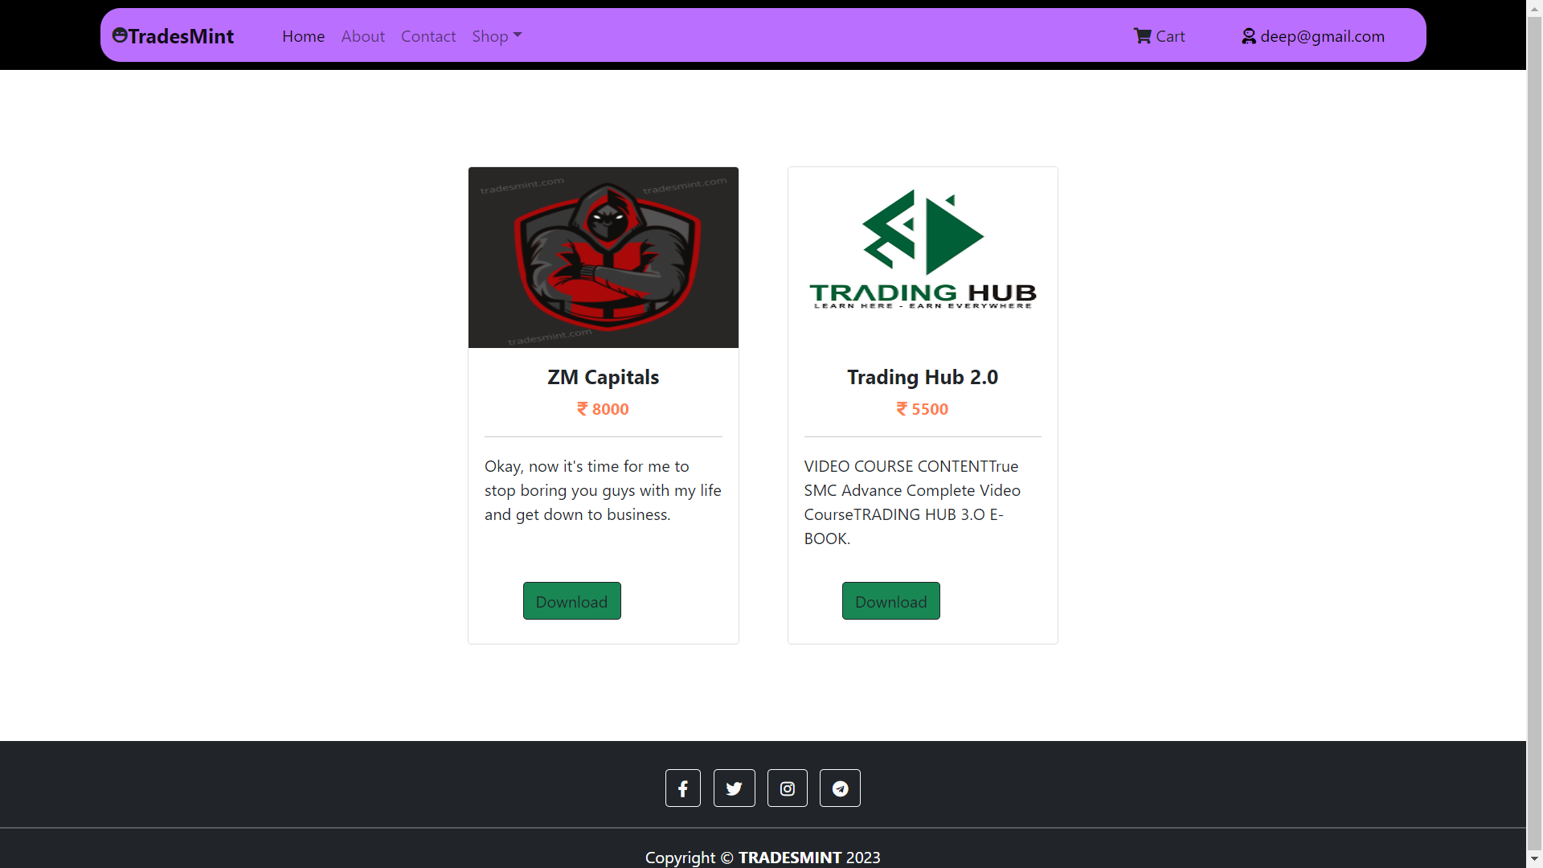

**-: Future Scope :-**

The Future Scope of our website is to provide the more functionality and features . And the site provides feedback facility to the user.

**-: Bibliography :-**

* [**www.bootstrap.com**](http://www.bootstrap.com)
* [**www.tradesmint.com**](http://www.tradesmint.com)
* **www.stackoverflow.com**

**Thank you for check it out our project !**